Playing Sports on My Period

Circle what kinds of products would be comfy for me to wear while I’m playing sports

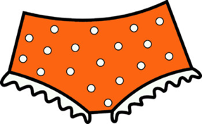
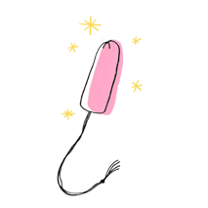
Tampons for sports

Thinner pads

Leak-proof period underwear

*Any answer will work for this question – once the type and utility of the products is explained, then students are free to choose whichever product they think will work for them

What should I use if I need to go swimming? A tampon

What can I do if I don’t like tampons but want to swim?

My period is heavy, so I could try to use a heavier tampon and/or a tampon made for being active
My period is light or almost gone, so I could wear a darker colored swimsuit (just in case)

Our friend, Olivia, loves to play sports, but she’s on her period and got pimples – oh no! What can we do to help Olivia?

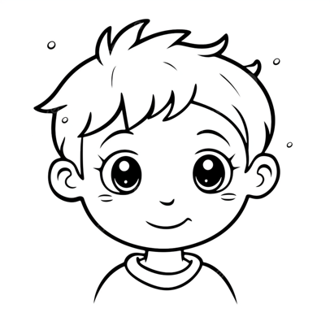
Ideas:

Wash her face right after practice

Remove make-up before playing sports

Avoid touching her face during the day to prevent infection

Use a face wash made for acne and apply lotion after

Clean sports equipment that touches your face and head

Wash jerseys (and other clothes) to prevent body acne

Wear a different sports bra for every practice to prevent body acne

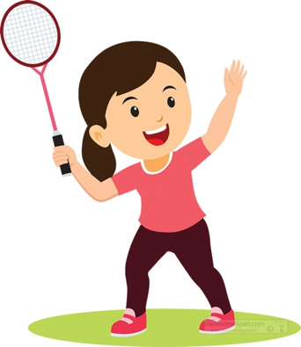
Instructions: Match the period problem to the period solution.
Go to bed earlier and eat some veggies and proteins with my meals

Take medicine for pain and tell my coach

Tell my parents and ask them if they think I should see a doctor

Cramps during practice

I’ve been moving my body so much, and I no longer get my period

I’m tired when I’m on my period and play sports

